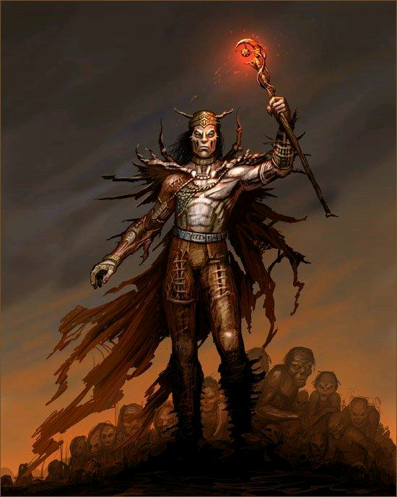
Contents
So what is the definition of a necromancer? 3
Necromantic magic 4
CHARACTER DEVELOPMENT 5
Necromantic Spells 6
1st Level 6
2nd Level 8
3rd Level 10
4th Level 13
5th Level 15


Welcome to the “Tome of the Dead”; perhaps welcome is the wrong greeting, it should be more like “Delve into these writings at your peril!”

Necromantic magic is arcane magic just as Earth, Fire, Water and Air are. However the major difference is it’s a new arcane magic derived from the energy of the living rather than an elemental source. The practice of this magic is inherently evil and results in the suffering and death of the individuals/creatures that the energy is taken from. Because it involves energy from a living creature the necromancer cannot as other elemental arcane spell casters use runes.

So what is the definition of a necromancer?
Necromancers summon and command the undead. Some of their ghoulish minions are capable of tearing men apart or casting their own death magic. The rotten corpses of the dead follow wherever the necromancer leads. Evil and twisted Necromancers bring the cursed and dead back from beyond the mortal realm to do their bidding. They are thus known by most people as evil beings that only live to torment the living, and this is completely true. Most hate people and will do anything to eliminate all life from the face of the Earth. They strive for power, power to corrupt and control.
The master of unholy magic, the Necromancer animates the dead and corrupts the living. Looking down on the Demonologist for needing to strike bargains for power, the Necromancer needs no such crutch, relying on his own mastery of death to dispatch his enemies.
The dark magic wielded by necromancer’s ranges from the unholy to pestilent corruption and the freezing touch of death. Through careful study they can develop the ability to call corpses from the earth to rise up and surround a foe or even attain lichdom, turning themselves into terrifying undead archmages. Most necromancers obviously do not reach this stage as they are normally extinguished by those of higher power before they become a threat.

Necromantic magic
This magic is frowned upon and feared by most races as the power that it uses is from living beings/animals. It unlike the other magic’s takes all the life force from the subject for energy transferral and conversion. In other words it kills the individual/creature from which the power is drawn. Because of this complete power absorption that takes place the mage can be overloaded with energy which their body cannot handle. Therefore they have to practice extreme caution, and take the energy from a individual/creature that possesses only the right amount of energy, consequently most practices of this art have learnt how far to destroy a individuals/creatures life-force before enacting the ritual to transfer the energy.

This magic is relatively young in the world of Yarm and is said to originate from the followers of "Garthos" who enacted sadistic rituals of pain and suffering on their people, all in the name of their god. It is believed that this religious faction has however been removed from the world of Yarm, but some believe it may have just gone underground to avoid persecution.
Because of the complexities of gaining energy to store for their heinous magic you would think that necromancers were at a disadvantage to other arcane spell casters, especially as they cannot cast their magic as runes as other arcane spell casters can. They do have however have a means to store their magic in vials that once drunk will fill them with the energy as though they have just preformed a ritual. This is only known amongst necromancers and is called “Blood Magic”

CHARACTER DEVELOPMENT
It may seem that there are limitations to been a necromancer, but because of plot and the way necromancers treat each other, as well as other races and classes a lot of information and abilities will come out in character development. If items become widely known amongst players then they will find their way into this tome.
Skills are much like other character development areas; you will need to think what your character would develop. For example they may choose to go down an Alchemy route, making poisons or potions to control; they may go down researching making different kinds of undead; they may want to develop wards to hide their element. Get the idea? Basically like skills for other character classes there is room to develop your character in a direction of evil and power

Necromantic Spells

1st Level
- DETECT MAGIC:- This enables the caster to detect if there is any magic cast on a particular item, it will immediately tell the caster if the sphere of magic is Earth or from the god “Julan” It only works on one object and the caster has to touch that object
  - Range: Touch Save: N/A
  - Duration: immediate

- QUESTION DEAD - The caster may ask one question requiring a simple Yes or No answer, and will be answered by any dead body that could have communicated whilst living.
Range : Touch
Save : N/A
Duration : 1 Question

- VERIFY DEAD - The caster detects whether corpses are quiescent undead. Any corpses in sight may be so tested when this spell is cast. It is near instantaneous.
Range : Sight
Save : N/A
Duration : I min.

- CORPSE VISAGE – Changes the appearance of the casters face, making him scary to look at. All foes that see his face within 10 pace radius run in Fear for a 20 count. This will only affect sentient beings. Those outside the 10 pace radius just think he/she looks ugly. (In game terms a mask is required by caster)
Range : 10 pace radius
Save : Applies - negates
Duration : 20 count

- ANIMATE CORSPE - A useful spell allowing the caster to move a dead body as if a zombie. The body is not undead, rather it is animated by Telekinesis ... as if a puppet. It cannot bear weight and is merely a party trick or a distraction. This can be used to animate body parts with more dexterity, for dramatic effect more than combat, feet, arms, hands, tails can be made to move as if alive.
Range : Touch
Save : N/A
Duration : One minute or until struck

2nd Level

- TERROR- The caster causes 1 target to Fear him/her. The victim will not approach or attack the caster for 1 hour and flees if pressed. This will only effect sentient beings.
Range : 10 paces
Save : Applies - negates
Duration : 1 hour

- RAISE UNDEAD - Requirements; corpse must be dead, but only something up to man sized, it has to have full muscle structure to be able to animate fully. The caster, at a touch animates the corpse. It has 1 hit point per location. It will not replace severed limbs, or replace damaged parts. It can only obey a single command, such as “attack” It lasts for 15 mins and once the corpse has been animated it can never be reanimated.
If performed as a ritual for 1 min, a more powerful form of undead could possibly be created. It will have 2 hits. Consult a ref when performing the ritual.
Range : Touch
Save : N/A
Duration : 15 mins

- GRIP OF DEATH - Undead arms magically rip from the floor ensnaring the victim, as they are mobile, constantly clawing at the target, moving and grabbing. Either hack at them with axe or sword, 6 hits for a sword or axe (Blunt does no damage). If someone has a strength feat of double or greater they can rip the hands from their grip and step free (Action of doing this required)
Range : 5 paces
Save : N/A
Duration : Until cut free, if stepped out of they disappear.

- IMPROVED QUESTION DEAD - The caster may ask one question and receive one answer, and will be answered by any dead body that could have communicated whilst living, with the intelligence of that creature/person.
Range : Touch
Save : N/A
Duration : 1 Question

3rd Level
- RAISE / CONTROL UNDEAD II
As Raise dead 1 but two corpses can be raised (2 x 1hp zombies), or one corpse with 2 HP, or one skeleton which will have 1 hp and take half damage from sharp weapons, (Skeleton must be present or all meat has to be stripped from corpse of target)
If performed as a ritual for 2 min, a more powerful form of undead could possibly be created. Consult a ref when performing the ritual.
Possibilities include;
A skeleton warrior. 2 hits per location and is half to sharp.
A greater zombie 4 hits, will emit slow gaseous poison when destroyed.

The control undead portion of this spell will allow the caster to control one undead of a level lower than this spell, i.e. a 1hp zombie. It will not allow the control of the ritual summoned undead unless a ritual of 4 mins is preformed on the restrained undead.
Range : Special
Save : N/A
Duration : 15 mins

2. STENCH OF DEAD - The necromancers emits a foul smelling gas that blinds and chokes nearby victims. Mixture of rotting eggs, sulphur and bile. Very unpleasant and leaves all attackers coughing and retching, unable to act other than crawl out of the radius of effect. The necromancer casting the spell can move and act as normal while the spell is up, however the concentration required limits combat, to removing items, picking items up and carrying them, he is also only able to move at walking speed. He cannot conduct the movements necessary for combat without negating his concentration.

The spell can be temporarily negated with air spells of Gust which will clear the air enough to breathe and see a way out, however the putrid stench will soon replenish. Armour and Armour 2 provide greater protection. Keeping the caster of the air spells completely unharmed by the spells effect, the winds stopping the effects from reaching the caster allowing, them to leave the area of effect.
Range : 10 paces radius of the caster
Save : N/A
Duration : 1 min

3. CORPSE EXPLOSION – The caster uses his/her life force on the remains of a recently dead (less than ten minutes) as a booby trap, making the corpse explode after the pre determined spell duration (Instant or up to one hour later) damage affects those in a five foot area round the corpse, doing 1point of damage to all exposed locations, armour lessens this damage. The power drain to the caster is that they are weakened and need to be supported for the hour after the spell has been cast.
Range : 10 paces
Save : N/A
Duration : Instant up to 1 hour

4. HEAL FROM OTHER - Gruesome spell in which the necromancers rips some of the life force from a prone victim, healing himself or his undead, and dealing damage to the prone victim (1 Point per location). The magic can heal undead on touch for 1 point per location, or heal the caster of 1 point per location. Note magic caster effects still happen. This spell can be cast twice if the mage has the power, thus taking 2 points and healing/dealing damage, however only one casting is required
Range : casters or 5 paces
Save : N/A, target must be prone
Duration : Instant

4th Level
- MIND FORTIFICATION: This enables the wizard to stop the effects of the magic drain for 60 mins, only one of these spells can be cast in a 24 hour period. After 60 mins, the mage has to lie down for 2 hours.
Range : Touch
Save : N/A
Duration :Immediate

- INVISABILITY TO UNDEAD: This will make the caster invisible to all undead for the time period as long as no offensive action is taken against anyone or anything.
Range : Touch
Save : N/A
Duration :5 mins

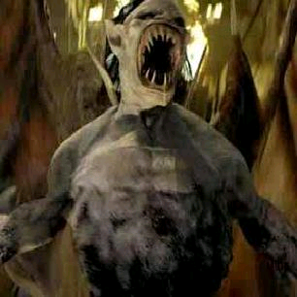
- RAISE / CONTROL UNDEAD III
As 2, but now they can raise 4 undead in one casting, or one zombie with 4 hp, or two skeletons with 2 HP.
If performed as a ritual for 3 min, a more powerful form of undead could possibly be created. Consult a ref when performing the ritual.
Possibilites include;
2 x ghouls (3 hit per loc) or
1 x ghast (4 hit per loc, corpse visage x 1) or
Skeleton lord (4 hit per loc, half to sharp)

The control undead portion of this spell will allow the caster to control one undead of a level lower than this spell, i.e. a 2 hp zombie. It will not allow the control of the ritual summoned undead unless a ritual of 6 mins is preformed on the restrained undead.
Range : Special
Save : N/A
Duration : 15 mins

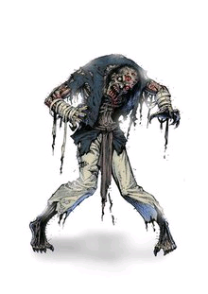

5th Level

- UNDEAD MASTERY - The caster may try to take control and command an undead creature (Controlled by someone or something else) by casting this spell and the power from another stored spell level. See table bellow; Mastery allows control for up to 1 hour. NOTE a powerful undead will attempt to throw off this most hated yoke, and do things that may put the caster in danger.
Range : Sight
Save : See above
Duration : Up to 1 hour

UNDEAD MASTERY Amount of energy required for control :-

Undead | Spell Energy level | Save
Wight’s | 3rd | No save
Ghouls | 3 x 3rd | No save
Wraiths | 5 x 3rd | Save applies
Mummy | 1 x 4th | No Save
Vampires | 2 x 5th | Save applies
Liches | 3 x 5th | Save applies

- RAISE / CONTROL UNDEAD IV As 3, but now they can raise 5 undead with 1 hp in one casting, or one zombie with 7 hp, or three skeletons with 2 HP.
If performed as a ritual for 5 min, a more powerful form of undead could possibly be created. Consult a ref when performing the ritual.
Possibilites include;
Wight. (4 hits per loc, corpse visage x 3)
Wraith, (10 global hits, can touch for Paralysis Slow: This means the place they are touched paralyses them for 30 seconds, Once the time has elapsed the effect wears off. )
Mummy (6 hits per location) has to be destroyed by fire. Touch for paralysis, person touched is paralysed fully till it is removed or for 30 mins.
Range : Special Save : N/A Duration : 15 mins

The control undead portion of this spell will allow the caster to control one undead of a level lower than this spell, i.e. a 4 hp zombie. It will not allow the control of the ritual summoned undead unless a ritual of 10 mins is preformed on the restrained undead.
Range : Special
Save : N/A
Duration : 15 mins

